The STEREO Heliospheric Imager

1. Introduction

Occupying 1 AU solar orbits, with one spacecraft leading the Earth, and one lagging the Earth, and separating from the Earth by 22º per year, the two NASA STEREO spacecraft provide vantage points from which one can view the Sun-Earth line, thus enabling studies of solar ejecta directed towards Earth. The STEREO multi-instrument remote sensing package, known as SECCHI (Sun-Earth Connection Coronal and Heliospheric Investigation; see Howard et al., 2000) includes the Heliospheric Imager (HI) (Socker et al., 2000; Defise et al., 2003, Harrison et al., 2005). It is this instrument, aboard STEREO, which provides wide-angle imaging of the heliosphere in order to study ejecta in interplanetary space.

HI consists of two small telescope systems mounted on the side of each STEREO spacecraft, which view space, sheltered from the glare of the Sun by a series of baffles. This system provides us with several important new opportunities for Coronal Mass Ejection (CME) (see Figure 1) research, including the following:

- The first opportunity to observe geo-effective CMEs along the Sun-Earth line in interplanetary space;
- The first opportunity to detect CMEs in a field of view which includes the Earth;
- The first opportunity to obtain stereographic views of CMEs in interplanetary space - to investigate CME structure, evolution and propagation in the heliosphere.

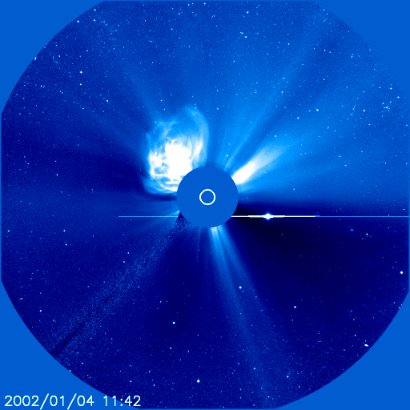

Figure 1 – An image from the LASCO C3 coronagraph aboard the Solar and Heliospheric Observatory (SOHO) showing a CME off the solar north-east limb. The image also shows stars, a planet and streamers. A CME can involve the ejection of 10¹²-10¹³ kg of matter.

The basic instrumental approach is through occultation and a baffle system, with wide-angle views of the heliosphere, achieving light rejection levels sufficient to view diffuse enhancements in density revealed by Thomson scattered photosphere light, from free electrons in the solar wind plasma.

The heritage for this instrument comes from the Solar Mass Ejection Imager (SMEI) instrument (Eyles et al., 2003), which is aboard the Coriolis spacecraft, launched in 2003. The SMEI instrument is also a wide-angle heliospheric imaging system, making use of three 60x3 degree field of view baffled camera systems which map the full sky as the spacecraft rotates. The basic aim of the instrument is similar to HI in that a baffle technique is used to image the weak, diffuse structures of the heliosphere. However, there are significant differences. There are two HI instruments. Each HI instrument is aboard a three-axis stabilized spacecraft, with a field of view looking back towards the Sun-Earth line. Thus, the HI instruments will allow a constant view of the heliosphere between the Sun and Earth, for two positions. This allows a unique capability for the study of Earth-directed CMEs and their three-dimensional structure.

2. Instrument Concept

The basic design concept for HI can be seen in Figure 2. The instrument is basically a box shape, of major dimension about 700 mm. A door covers the optical and baffle systems during launch and the initial cruise phase activities. The door is opened once during instrument commissioning and it remains open. The two telescope/camera systems, known as HI-1 and HI-2 are buried within a baffle system as shown in Figure 2. The direction to the Sun is shown; the Sun remains below the vanes of the forward baffle system. The detectors are CCD devices, which are cooled by radiators facing anti-Sunward space. The relationship between the two fields of view of the HI-1 and HI-2 telescopes is shown in the optical layout of the bottom panel of Figure 2.

The performance specifications for HI are listed in Table 1. The HI-1 and HI-2 telescopes are directed to angles of 13.65 and 53.35 degrees from the principal axis of the instrument, which in turn is tilted upwards by 0.33 degrees to ensure that the Sun is sufficiently below the baffle horizon. Thus, the two fields of view are nominally set to 13.98 and 53.68 degrees from the Sun, along the ecliptic line, with fields of view of 20 and 70 degrees, respectively. This provides on overlap of about 5 degrees.

The HI detectors are CCDs with 2048x2048 pixels of 13.5 micron. These are binned on board to 1024x1024, resulting in image pixel angular sizes of 70 arcsec (HI-1) and 4 arcmin (HI-2). For each telescope, Table 1 lists a nominal exposure time range and a nominal number of exposures per image. As detailed later, to obtain sufficient statistical accuracy, long-duration exposures are required. However, the rate of cosmic ray hits would compromise the images. Thus, short exposures are made and cleaned on board and a number of exposures are summed to produce an image to be returned.

 | HI-1 | HI-2
Direction of Centre of FOV | 13.98 degrees | 53.68 degrees
Angular Field of View | 20 degrees | 70 degrees
Angular Range | 3.98-23.98 degrees | 18.68-88.68 degrees
Image Array (2x2 binning) | 1024x1024 | 1024x1024
Image Pixel Size | 70 arcsec | 4 arcmin
Spectral Bandpass | 630-730 nm | 400-1000 nm
Exposure time | 12-20 s | 60-90 s
Nominal Exposures Per Image | 70 | 50
Nominal Image Cadence | 60 min | 120 min
Brightness Sensitivity | 3 x 10⁻¹⁵ Bsun | 3 x 10⁻¹⁶ Bsun
Straylight Rejection (outer edge) | 3 x 10⁻¹³ Bsun | 10⁻¹⁴ Bsun

Table 1 – Performance Specifications of the HI Instruments

The geometrical layout of the fields of view of the SECCHI instruments is shown in Figure 3. The HI-1 and HI-2 fields provide an opening angle from the solar equator at 45º, chosen to match the average size of a CME. The configuration provides a view of the Sun-Earth line from the STEREO coronagraph fields to the Earth and beyond. At the start of the mission, the Earth is just outside the HI-2 field of view; it moves into the field as the mission progresses, as shown in Figure 3. It should be remembered that this is done from two spacecraft at equal planetary angles (Earth-Sun-spacecraft), providing a stereographic view.

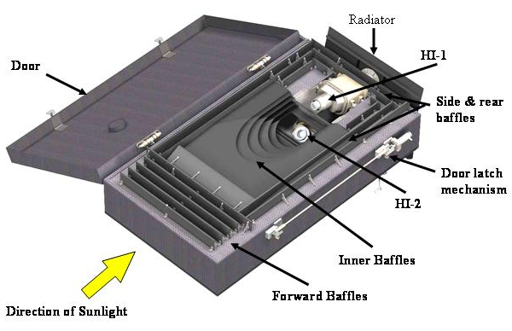

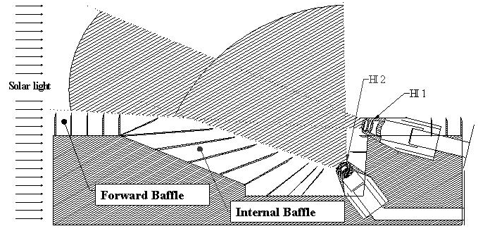

Figure 2 –Top: The Heliospheric Imager design concept. Bottom: A side view of the optical configuration, demonstrating the two fields of view of the instrument.

Figure 3 also indicates some of the major contributions to the intensities which will be recorded by the HI instruments, in particular the F-corona (zodiacal light) and stellar intensities, as well as anticipated CME intensities. One point to note immediately is that the F-coronal intensity is about two orders of magnitude brighter than the anticipated CME signal and this defines the basic operation principle of the instrument. One must accumulate for long durations such that the CME signal is stronger than the noise levels of the F-corona, in order for us to extract the CME signal. Thus, as mentioned above, cosmic ray contributions are such that the required accumulations must be made up of a sum of many shorter duration exposures each of which is cleaned automatically of cosmic ray hits before on-board summing.

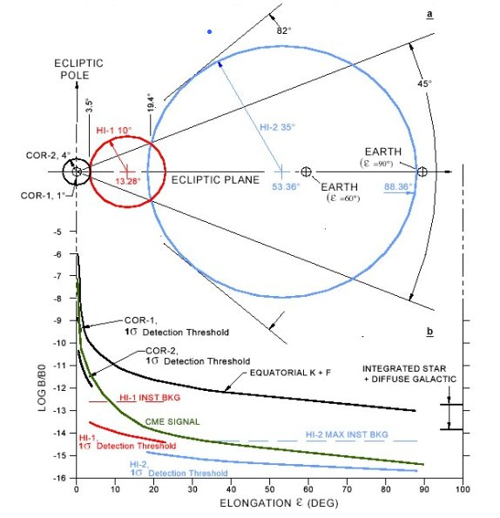
Figure 3 - The geometrical layout of the HI fields of view and the major intensity contributions (from Socker et al. 2000).

The anticipated instrument stray light level must be at least an order of magnitude less than the F-coronal signal which can be seen, from Figure 3, to require levels of better than ~10⁻¹³ Bsun for HI-1 and ~10⁻¹⁴ Bsun for HI-2. In contrast, the brightness sensitivity requirement is based on the need to extract the CME signal from the other signal sources which demands the detection of CME intensities down to 3 x 10⁻¹⁵ Bsun and 3 x 10⁻¹⁶ Bsun.

The complexity of the subtraction of the CME signal from the data, and the various contributions that make up the raw signal deserve further description, and this is addressed below.

The principal hardware development for HI was centred at Birmingham University, with camera design and development work and some thermal work provided by the Rutherford Appleton Laboratory. The Centre Spatial de Liege, Belgium, provided optical design, analysis and test effort. Numerous aspects of the assembly, integration and test work, and the overall SECCHI management overseeing the HI activities have been performed by the US Naval Research Laboratory. The HI concept was developed by Dennis Socker of the Naval Research Laboratory.

3. Baffle Design

The baffle design is the key to the HI concept. As shown in Figure 2, the baffle sub-systems consist of a forward baffle, a perimeter baffle and the internal baffle system.

The forward baffle is designed to reject the solar disk intensity, reducing straylight to the required levels. The perimeter baffle is principally aimed at rejecting straylight from the spacecraft, and the internal baffle system is aimed at rejecting light from the Earth and stars. The forward baffle protects the HI-1 and HI-2 optical systems from solar light using a knife-edge cascade system, as demonstrated in Figure 4. The five-vane system allows the required rejection to be achieved, as computed using Fresnel’s second order approximation of the Fresnel-Kirchhoff diffraction integral for a semi-infinite half-screen. The schematic plot on the right hand side of Figure 3 shows the nature of the function log(B/Bo), where Bo is the solar brightness, plotted with distance below the hrorizon. The heights and separations of the five vanes have been optimised to form an arc ensuring that the n+1th vane is in the shadow of the n-1th vane. A global rejection curve for this system is computed in Figure 4 (bottom panel) and measurements made using a full 5-vane mock up baffle in ambient and vacuum conditions show good adherence to the predicted rejection levels.

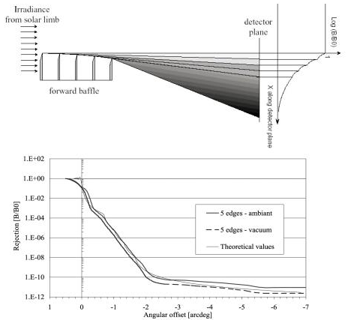

Figure 4 – The diffractive cascade knife-edge system of the forward baffle system

The relevant angular offset range for HI-1 for the test set-up recorded in the lower panel of Figure 4 is 1.5-3.3º providing a rejection of order 10⁻⁸ to 10⁻¹¹ B/Bo. For HI-2 the rejection is of order 3 x 10⁻¹².

The perimeter baffle (lateral and rear side vane systems) protects the HI optical systems from reflection of photospheric light off spacecraft elements lying below the horizon defined by the baffles, including the High Gain Antenna, door mechanisms etc… However, one spacecraft element does rise above the baffles, namely the 6 m long monopole antenna of the SWAVES instrument. Calculations show that scattered light from the monopole will be adequately trapped by the internal baffle system.

The internal baffle system consists of layers of vanes which catch unwanted light from multiple reflections into the HI-1 and HI-2 optical systems, mainly from stars, planets the Earth, zodiacal light and the SWAVES monopole. Although the Earth, stars and planets are within the HI fields, the internal baffle system limits the uniform background scattered into the optical systems.

4. Optical Systems

Figure 2 shows the locations of the HI-1 and HI-2 optical units. The optical configurations for these are shown in Figure 5. These systems have been designed to cater for wide-angle optics, with 20º and 70º diameter fields of view, respectively, with good ghost rejection, using radiation tolerant glasses (as indicated by the notation for each lens), to cater for the deep space environment. The HI-1 lens system has a focal length of 78 mm and aperture of 16 mm and the HI-2 system has a 20 mm focal length and a 7 mm aperture. The design is optimised to minimise the RMS spot diameter and anticipates an extended thermal range from –20ºC to +30ºC. The detector system at the focus in each case is a 2048x2048 pixel 13.5 micron CCD.

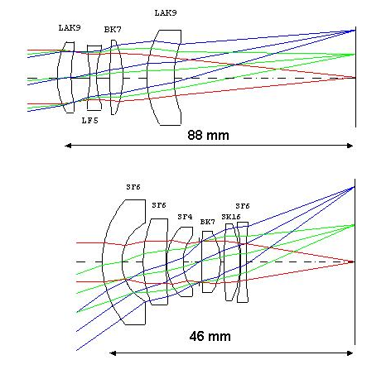
Figure 5 – The optical configurations of the HI-1 (upper) and HI-2 (lower) lens barrels

The lens assemblies have undergone detailed design and test procedures and one of the key requirements is on the stray light rejection; the lens systems are mounted in blackened barrels. For HI-1 and HI-2 stray light rejection is measured to be at 10⁻³ or lower. This combined with the stray light measurement of the front baffle, shown in Figure 4, provides an overall light rejection level of 10⁻¹¹-10⁻¹⁴ for HI-1 and 3 x 10⁻¹⁵ for HI-2. These values are better than the straylight requirements shown in Table 1.

5. Instrument Performance and Contributions to the HI intensities

Table 2 summarises the instrument efficiency, collecting area and other relevant parameters. The ultimate aim of this table is to estimate the intensity of the solar disc, for comparison to stellar, planetary and other sources. Knowing the mean photon energies of each system, and the size of the solar disc, one can calculate the solar intensity for HI-1 and HI-2 and the solar intensity per pixel.

Solar Constant [C] | 1372 Wm⁻²
HI-1 collecting area (16 mm diam) [A] | 2 x 10⁻⁴ m²
HI-2 collecting area (7 mm diam) [A] | 4 x 10⁻⁵ m²
Detector Quantum Efficiency assumed [DQE] | 0.9
Fraction of black body curve viewed [bb] | 0.1 (HI-1) and 0.64 (HI-2)
Mean photon energy (HI-1) [E] | 2.92 x 10⁻¹⁹ J (680 nm)
Mean photon energy (HI-2) [E] | 3.31 x 10⁻¹⁹ J (600 nm)
Solar Image area (HI-1) [pix] | 2076 (35 arcsec pixels, i.e. 2kx2k array)
Solar Image area (HI-2) [pix] | 176 (2 arcmin pixels, i.e. 2kx2k array)
Solar Intensity (Bo) = [C.A.DQE.bb/E] | HI-1: 8.46 x 10¹⁶photons/s  HI-2: 9.55 x 10¹⁶ photons/s
Solar Intensity per pixel = [C.A.DQE.bb/E.pix] | HI-1: 4.08 x 10¹³ photons.s⁻¹.pix⁻¹.  HI-2: 5.43 x 10¹⁴ photons.s⁻¹.pix⁻¹.

Table 2 – HI instrument efficiencies, collecting areas and intensities.

To assess the performance of the HI instrument, we consider briefly the intensity contributions of significant sources. This is described in detail by Harrison et al. (2005). Figure 6 shows a simulated image for HI-2 which includes all sources outlined below.

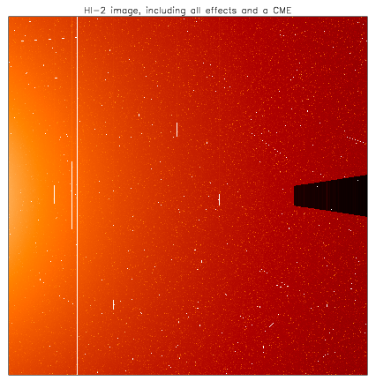

Figure 6 – A simulated HI-2 60 s exposure including all anticipated effects (see text). The Sun is to the left and the axis of the image running from left to right is the ecliptic plane.

Dust particles in the inner heliosphere form the so-called F-corona. The intensity of the F-corona is a function of elongation, the anticipated intensity distribution being given by Koutchmy and Lamy (1985).

Another major contribution to the HI images is the detection of planets. For the specific simulation we illustrate shown in Figure 6, the planets Mercury, Venus, Mars and Jupiter are included. These are the four brightest sources on the ecliptic plane (centre line). We have assumed that each planet is at its brightest magnitude. Having all major planets at their brightest intensity in one HI field would be rare; this extreme situation is used to simulate a worst case condition. The planetary and stellar magnitudes for this study are taken from Norton’s Star Atlas (1998).

The planets, and, indeed, the stars, are point sources, which are added to the HI fields of view. Table 3 shows the maximum magnitude of the major planets and the brightness relative to the Sun, of the planets and some stars. To obtain the count-rate in photons per second for a point source in HI-1 or HI-2 we can compare to the Sun, using the figures from Table 2. The planetary intensities listed are the maximum intensities viewed from Earth. Since the STEREO spacecraft are in 1 AU solar orbits, the same values apply.

The differences in the fraction of the black body curve detected by HI-1 and HI-2, combined with the different collecting areas, almost cancel out, resulting in very similar intensities in HI-1 and HI-2 for the planets and stars.

Object | Max Magnitude (m) | Brightness (B =10^{(-m/2.5)}) | B/Bo (Bo = 5.25x10¹⁰) | HI-1 Photons/s | HI-2 Photons/s
Sun | -26.8 | 5.25 x 10¹⁰ | 1 | 8.46 x 10¹⁶ | 9.55 x 10¹⁶
Venus | -4.6 | 69.2 | 1.3 x 10⁻⁹ | 1.10 x 10⁸ | 1.24 x 10⁸
Jupiter | -2.6 | 11 | 2.1 x 10⁻¹⁰ | 1.78 x 10⁷ | 2.00 x 10⁷
Mercury | -1.8 | 5.2 | 9.9 x 10⁻¹¹ | 8.38 x 10⁶ | 9.45 x 10⁶
Mars | -1.6 | 4.4 | 8.4 x 10⁻¹¹ | 7.11 x 10⁶ | 8.02 x 10⁶
Sirius | -1.47 | 3.9 | 7.4 x 10⁻¹¹ | 6.26 x 10⁶ | 7.07 x 10⁶
Arcturus | -0.06 | 1.1 | 2.1 x 10⁻¹¹ | 1.78 x 10⁶ | 2.00 x 10⁶
Rigil | 0 | 1 | 1.9 x 10⁻¹¹ | 1.61 x 10⁶ | 1.81 x 10⁶
Mag 1.0 | 1 | 0.4 | 7.6 x 10⁻¹² | 6.43 x 10⁵ | 7.26 x 10⁵
Mag 2.0 | 2 | 0.2 | 3.8 x 10⁻¹² | 3.21 x 10⁵ | 3.63 x 10⁵
Mag 3.0 | 3 | 0.06 | 1.1 x 10⁻¹² | 9.31 x 10⁴ | 1.05 x 10⁵
Mag 4.0 | 4 | 0.03 | 5.7 x 10⁻¹³ | 4.82 x 10⁴ | 5.44 x 10⁴
Mag 5.0 | 5 | 0.01 | 1.9 x 10⁻¹³ | 1.61 x 10⁴ | 1.81 x 10⁴
Mag 6.0 | 6 | 0.004 | 7.6 x 10⁻¹⁴ | 6.43 x 10³ | 7.27 x 10³
Mag 7.0 | 7 | 0.0016 | 3.0 x 10⁻¹⁴ | 2.54 x 10³ | 2.87 x 10³
Mag 8.0 | 8 | 0.00063 | 1.2 x 10⁻¹⁴ | 1.02 x 10³ | 1.15 x 10³
Mag 9.0 | 9 | 0.00025 | 4.8 x 10⁻¹⁵ | 4.06 x 10² | 4.59 x 10²
Mag 10.0 | 10 | 0.00010 | 1.9 x 10⁻¹⁵ | 1.61 x 10² | 1.82 x 10²
Mag 11.0 | 11 | 0.00004 | 7.6 x 10⁻¹⁶ | 6.43 x 10¹ | 7.27 x 10¹
Mag 12.0 | 12 | 0.000016 | 3.0 x 10⁻¹⁶ | 2.54 x 10¹ | 2.87 x 10¹

Table 3 – Planetary and Stellar Intensities

Optical modelling shows that the HI-1 and HI-2 RMS size for a point source is of order 50 μm and 100 μm in the worst case, respectively. Note that the pixel size is 13.5 μm. Calculations show that of order 34 % of the spot energy is in the central pixel and this information, along with the RMS value, is used to model a basic Gaussian shaped point spread function (PSF). This is applied to all point sources in the simulation.

The straylight contribution can be calculated from the measurements given above and are included in Figure 6.

The stellar contribution is significant. The approximate number of stars per square degree, as a function of magnitude has been published (e.g. Allen, C.W., 2000) and we make use of this, projecting to the size of the HI fields of view. We do include a few stars of magnitude brighter than 0.0 in each calculation, which would be rather unusual, but is required to estimate the worst case situation. Thus, for the HI-2 simulation shown we assume the inclusion of Sirius, Arcturus and Rigil. We also assume that there is at least one star for each magnitude in the field of view. The stellar magnitudes and intensities are included in Table 3 and Table 4 shows the anticipated stellar distribution for the HI fields of view. Each star is added to the field of the modelled image at a location estimated using a random number generator. The PSF is applied to each star.

Mag | No. in HI-1 field | No. in HI-2 field
-1.47 (Sirius) | 1 | 1
-0.06 (Arcturus) | 1 | 1
0.0 (Rigil) | 1 | 1
1.0 | 1 | 1
2.0 | 1 | 4
3.0 | 1 | 14
4.0 | 4 | 48
5.0 | 13 | 150
6.0 | 39 | 450
7.0 | 109 | 1335
8.0 | 314 | 3848
9.0 | 884 | 10843
10.0 | 2552 | 31277
11.0 | 6867 | 84156
12.0 | 18068 | 221414

Table 4 – Stellar numbers anticipated in the two HI fields of view for different magnitudes

To assess the performance of the HI we must include noise. For the simulation, a Poisson-like form is assumed. To do this, we modify the intensity of each pixel using a software function ‘seeded’ by a random number generator. This is a simple-minded yet effective approach for the purpose at hand. Noise is included in Figure 6.

The CCD pixels saturate at 200,000 electrons, i.e. 200,000/DQE photons, where DQE is the detector quantum efficiency. At a DQE of about 80 %, this gives a value at 250,000 photons or log(Photons/pixel) = 5.4. When a pixel saturates, the charge is ‘spilled’ or distributed along the column, rather than along rows (across columns). This saturation effect is called blooming. Cross-column saturation is subdued by the detector design. The level to which saturation can be confined to columns has been confirmed with detector tests. Such confinement has been confirmed for pixel intensities brighter than the brightest values one would expect from Venus and Jupiter. However, for much brighter intensities, such as intensities which would be experienced if the Earth was imaged in the early phase of the mission, would swamp the CCD detector.

In Figure 6, this effect can be seen for the four planets and a few of the brightest stars. Note again, that having so many sources at that intensity in one field of view is extreme. This effect can be seen in the SOHO LASCO image of Figure 1.

The HI instrument does not have a shutter. The consequences of this are shown schematically in Figure 7. For the 2048x2048 CCD array, let us examine pixel (n,m) of an exposed image, and an exposure time of N seconds. The read-out direction of the CCD is downwards and the line transfer rate is 2048 μs, resulting in a 'pseudo exposure' at every line position along the column under the pixel location. In other words in addition to the nominal exposure, there are (m minus 1) exposures of 2048 μs, which must be added to the nominal exposure intensity because there is no shutter.

In addition, the CCD is cleared using a 150 μs line transfer rate, so we must also add contributions from the (2048 minus m) pixels above the nominal location with an exposure of 150 μs at each location.

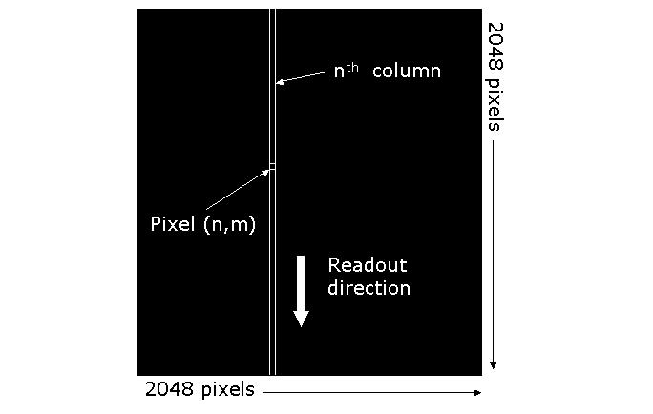
Figure 7 – A schematic of the non-shutter read-out

In mathematical form, the total count, T, for pixel (n,m) is given by:

T(n,m) = [N x I(n,m)] + Σ_{(y=m+1,2047)} (150 x 10⁻⁶) x I(n,y) + Σ_{(y=0,m-1)} (2048 x 10⁻⁶) x I(n,y)

where the count rate for pixel (x,y) is given by I(x,y).

The effect is to introduce a background intensity gradient across the image readout direction, with step-function increases in this background in the columns below bright sources. The difference between the 60 s exposure and the 2048 μs ‘exposures’ for HI-2, for example, means that most stars produce an insignificant effect. In principle, the effect can be calculated and corrected.

The HI instruments are designed to view the Sun-Earth line and in the early days of the mission, with the spacecraft closest to the Earth, the intensities of the Earth and Moon in the HI2 instrument will be so large that they would saturate large sections of the CCD. In order to prevent this, a mask has been designed for the HI2 instrument that will block light from the Earth and Moon until the spacecraft have moved sufficiently far from the Earth that the intensity of the planet will be no greater than that of Venus at its brightest.

The occulter has been designed to account for the expected tolerances in the pointing accuracy of the spacecraft while minimising the area of the CCD that is obscured. As the mission evolves and the spacecraft move away from the Earth along the Earth’s orbital path, the image of the Earth and Moon will decrease in size and drift inwards from the right hand side of the HI-2 image. The occulter is therefore a rhomboid extending 5.67mm (420 pixels) in length over the central right-hand edge of the CCD array, tapering from a width of 3.24mm (240 pixels) at the CCD edge to a width of 1.5mm (111 pixels) at the tip. The occulter can be seen on the right hand side of the image shown in Figure 6.

Cosmic rays are added in random locations assuming a similar rate to those detected by the CDS instrument on the SOHO (Solar and Heliospheric Observatory) spacecraft (Pike and Harrison, 2000). Thus, we assume 4 hits.cm⁻²s⁻¹. SOHO is located in an L1 orbit, 1.5 million km Sunward of the Earth, but the basic particle environment should be somewhat similar to that expected for STEREO. HI uses a 2048x2048 array of 13.5 micron pixels, i.e. 2.76 cm x 2.76 cm, which suggests 30.5 hits per second on each of the HI CCDs. In principle, cosmic ray hits can be point-like (single pixel), can spill into adjacent pixels or even be tracks. Thus, the simulated image of Figure 7 assumes cosmic rays incident from any direction.

To put the particle hit rate in perspective, note that for a 60 s exposure, we expect 1,830 pixel hits out of the 4,194,304 pixels, i.e. 0.04 % of pixels are effected. These will be cleaned on board before exposure summing. If such on board summing was not performed and accumulations of order 1 hour were required, we would expect 2.6 % of all pixels to be contaminated through cosmic ray hits.

Given all of the effects listed above, we have a requirement to extract the signal from a CME. The simulated image, in fact, includes a simple CME-like feature. It cannot be seen in the raw image. The CME is a simple, narrow loop set at an intensity of 10⁻¹⁵ Bo (see Figure 3). Given its location in the HI-2 field, this simulated CME is an order of magnitude weaker than anticipated events. To extract the CME signal we must accumulate exposures, to ensure that the CME intensity becomes significantly brighter than the noise level. As mentioned above, we do this by summing a series of exposures and cleaning each of cosmic rays, on board, prior to summing.

Once a summed image has been completed and returned, the CME signal is identified either by the subtraction of a base-frame (in which we estimate the F-coronal intensity) or the subtraction of a recent image. These approaches are in common use for coronagraph observations. A subtraction of a recent image displays recent changes to the heliospheric brightness. However, if regular ‘background’ base-frames are calculated, from the anticipated coronal and other contributing intensities, we can provide regular monitoring of CMEs and a number of other phenomena. A simulated base-frame is extracted from the simulated HI-2 image to produce the image of Figure 8. This reveals the CME, which was not identifiable from the exposure in Figure 6.

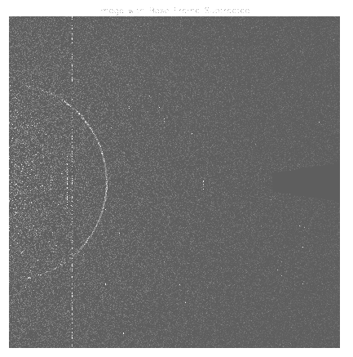

Figure 8 – A 60-exposue 60 s HI-2 sequence with the calculated base-frame subtracted. The CME loop is now identified.

This basic demonstration, utilising all known effects in the HI exposures, and including extreme sources (bright planets and stars) and a weak CME, confirms that the HI performance is well able to be applied to the objectives set for the STEREO mission.

References

Allen, C.W., Astrophysical Quantities, Springer-Verlag, New York, ISBN 0387987460, 2000.
Defise, J., Halain, J., Mazy, E., Rochus, P. P., Howard, R. A., Moses, J. D., Socker, D. G., Harrison, R. A. & Simnett, G. M., Design and tests for the heliospheric imager of the STEREO mission, in ‘Innovative Telescopes and Instrumentation for Solar Astrophysics’, Eds S.L. Keil, S.V. Avakyan . Proc SPIE 4853, 12-22, 2003.
Eyles, C.J., Simnett, G.M., Cooke, M.P., Jackson, B.V., Buffington, A., Hick, P.P., Waltham, N.R., King, J.M., Anderson, P.A., Holladay, P.E., Solar Phys., 217, 319-347, 2003.
Harrison, R.A., Davis, C.J., Eyles, C.J., The STEREO Heliospheric Imager: How to detect CMEs in the heliosphere, Adv. Space Res. 36, 1512-1523, 2005.
Howard, R.A., Moses, J.D., Socker, D.G., and the SECCHI consortium, Sun Earth Connection Coronal and Heliospheric Investigation (SECCHI), in ‘Instrumentation for UV/EUV Astronomy and Solar Missions’, (eds) S. Fineschi, C.M. Korendyke, O.H. Siegmund, B.E. Woodgate, SPIE (Washington) 4139, 259-283, 2000.
Koutchmy, S. and Lamy, P.L., The F-corona and the circum-solar dust evidences and properties, in ‘Properties and Interactions of the Interplanetary Dust’ (eds) R.H. Giese and P. Lamy, IAU Colloq. 85, 63, D. Reidel, Dordrecht, ISBN 90-277-2115-7, 1985.
Norton’s Star Atlas, (ed) I. Ridpath, Longman, London, ISBN 0582312833, 1998.
Pike, C.D. and Harrison, R.A., Long-duration cosmic ray modulation from a Sun-Earth L1 orbit, Astron. Astrophys.362, L21-L24, 2000.
Socker, D.G., Howard, R.A., Korendyke, C.M., Simnett, G.M., Webb, D.F., The NASA Solar Terrestrial Relations Observatory (STEREO) mission Heliospheric Imager, in ‘Instrumentation for UV/EUV Astronomy and Solar Missions’, (eds) S. Fineschi, C.M. Korendyke, O.H. Siegmund, B.E. Woodgate, SPIE (Washington) 4139, 284-293, 2000.

